## GLOBALIZATION TESTING

Developing the software for multiple languages is called as Globalization. Testing the software which is developed for multiple languages is called as Globalization Testing.

**Types of Globalization Testing:**

1. Internationalization Testing (I18N Testing)
2. Localization Testing (L10N Testing)

**How application works for multiple languages?**

1. First TE will open the browser and enter the URL. When he clicks go, request goes to server. The request object has 2 things: (1) Page name (2) Language code [In this example page name= Welcome, Language code= English]
2. Server is waiting for the request. As soon as the request object comes in, it goes and checks for page name. [In this example page name= Welcome. So, it runs welcome.jsp]
3. The program starts running, it has 2 sections. The 1st section runs and receives the request object and goes inside the request object and checks the language code. [In this example language code= English. So, it connects with English

property files. So, the connection b/w Program files and Property Files are established]

1. The remaining program copies the content from the property files and displays it in the browser.

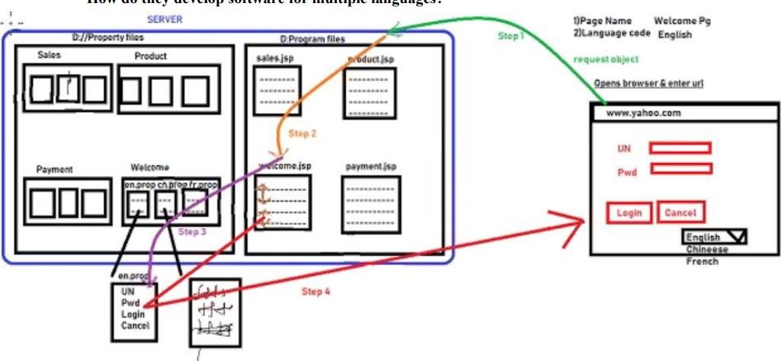

**What is I18N Testing?**

Testing the application which is developed for multiple languages is called I18N Testing.

Here we check whether:

Content is in right language or not

We check whether right content is displayed in right place or not

We check whether features are broken if the language is changed

**How to do I18N testing for Chinese language?**

a) Go to Chinese property file

1. Add prefix and suffix to the content
2. Save the property file
3. Open the application & select the language (Chinese) corresponding page comes
4. I will check for prefix, if prefix is correct means content is in right language
5. I will check for suffix, if suffix is correct means content is in right place

.

**Localization Testing**

Check whether the certain features are changing locally according to the country standards.

Example: Here we check currency format, date and time format, pin code format

(in interview if they ask)

*How do we test images?*

* 1. Image should not contain the text
  2. If you want to have the text on the image then multiple images must be present in the server
  3. Tool tip (or) alt tag must be displayed in the corresponding language

kruthana